Ideation Phase
Empathize & Discover
Date | 17/09/22
Team ID | PNT2022TMID48099
Project Name | Hazardous Area Monitoring for Industrial Plant  powered by IoT
Maximum Marks | 4marks

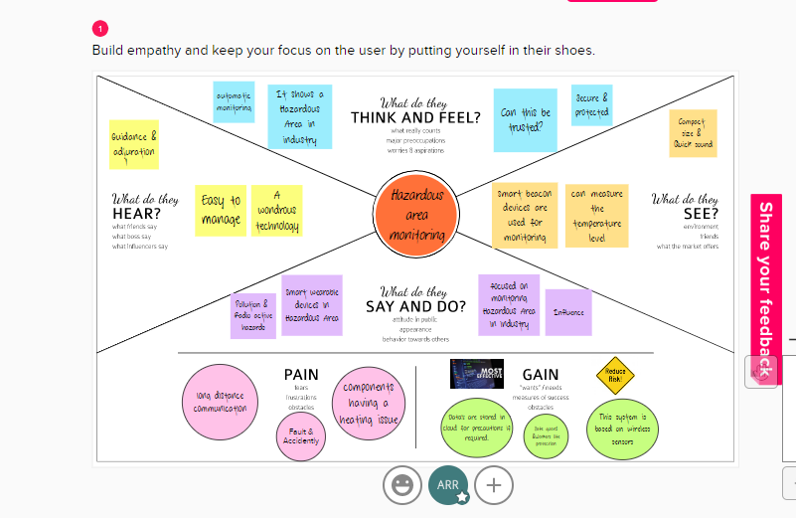
REFERENCE LINK:
https://app.mural.co/invitation/mural/iotmakers7542/1662826043578?sender=u254a533787913ed14aa43587&key=d37b87bf-d759-4a68-9a2e-e7b25f1fb9da

